

AUTOMATIC FISH FEEDER SYSTEM

A MINI PROJECT REPORT

Submitted by

ARUNESH KUMAR G | (9517202109250)
NITHISH KANNAN M | (9517202109252)
VISHNU S K | (9517202109254)

in partial fulfillment for the award of the
degree of

BACHELOR OF TECHNOLOGY

IN

ARTIFICIAL INTELLIGENCE AND DATA SCIENCE

MEPCO SCHLENK ENGINEERING COLLEGE, SIVAKASI

AUTONOMOUS

ANNA UNIVERSITY : CHENNAI 600 025

OCTOBER 2024

MEPCO SCHLENK ENGINEERING COLLEGE, S IVAKASI
AUTONOMOUS
DEPARTMENT OF ARTIFICIAL INTELLIGENCE AND DATA SCIENCE



BONAFIDE CERTIFICATE

This is to certify that it is the bonafide work of “AruneshKumar.G (2021090250), Vishnu SK (2021090254), Nithish Kannan.M (2021090252)” for the Mini project titled “AUTOMATIC FISH FEEDER SYSTEM” in 19AD752–Intelligent Systems for IOT Laboratory during the seventh semester July 2024–October 2024 under my supervision.

SIGNATURE SIGNATURE

Dr.A.Shenbagarajan , Dr. J. Angela Jennifa Sujana,
Associate Professor, Professor & Head,
AI&DS Department, AI&DS Department,
Mepco Schlenk Engg.College, Mepco Schlenk Engg.College,
Autonomus Autonomus
Sivakasi Sivakasi

ABSTRACT

The Automatic Fish Feeder is a device which it helps to feed food for fish .If the person worrying about not feeding food for fish.So we come up with IOT Technology with Cloud application.By using this device you can feed food for fish at home without worrying about it.It can be done with your phone or other devices by feeding food with help of these two methodology as automatic or manually.The automatic method is timing of food which can be set through this device by the person.while the Manual method needs to be controlled by the person to feed food for their fish pet.This device is easy to use and can be loaded with food for fish by specific quantity . So due to this person don’t need worry about not feeding food for their pet . By giving this solution it improves fish health without any risks , So with help of Automatic Fish Feeder the person doesn’t need worrying about and fish is also being healthy.

ACKNOWLEDGEMENT
First and foremost we praise and thank “The Almighty”, the lord of all creations, who by his abundant grace has sustained us and helped us to work on this project successfully.
We really find unique pleasure and immense gratitude in thanking our respected management members, who is the backbone of our college.
A deep bouquet of thanks to respected Principal Dr.S.Arivazhagan M.E.,Ph.D., for having provided the facilities required for our mini project.

We sincerely thank our Head of the Department Dr. J. Angela Jennifa Sujana M.E.,Ph.D., Professor & Head, Department of Artificial Intelligence and Data Science, for her guidance and support throughout the mini project .
We extremely thank our project coordinator Dr.A.Shenbagarajan M.E.,Ph.D, Associate Professor, Department of Artificial Intelligence and Data Science and Dr.E.Emerson Nithiyaraj M.E., Ph.D, Assistant Professor , who inspired us and supported us throughout the mini project.
We extend our heartfelt thanks and profound gratitude to all the faculty members of Artificial Intelligence and Data Science department for their kind help during our mini project work.
We also thank our parents and our friends who had been providing us with constant support during the course of the mini project work.

TABLE OF CONTENTS

S.No |  |  | Pg No
1 | INTRODUCTION |  | 7
 | 1.1 | Introduction | 7
 | 1.2 | Objectives | 8
 | 1.3 | Scope of the project | 9
2 | PROPOSED SOLUTION
 | 2.1 | Block Diagram | 10
 | 2.2 | Modules Description | 132
 | 2.3 | Software Requirements | 12
 | 2.4 | Hardware Requirements | 13
 | 2.5 | Circuit Diagram | 15
 | 2.6 | Esp32 WiFi module | 16
3 | IMPLEMENTATION
 | 3.1 | Source Code | 16
 | 3.2 | Flowchart | 19
 | 3.3 | Experimental Results | 21
4 | CONCLUSION |  | 22
 | REFERENCES |  | 23

LIST OF FIGURES

Fig No | NAME | Pg No
2.1 | Block Diagram | 10
2.3.5 | Servo motor | 14
2.3.6 | ESP32 WiFi Module | 15
2.7.1 | Circuit connection | 15
3.1 | Flowchart | 19
3.2  3.3 | Project Prototype  Final Setup Result | 20  21

Introduction

CHAPTER 1 INTRODUCTION

Aquarium maintenance is essential for ensuring the health and well-being of fish, and one of the most critical aspects of this is feeding. Regular feeding in the right quantities is crucial to maintaining fish health, preventing stress, and avoiding health complications. However, many fish owners find it difficult to maintain consistent feeding schedules due to their busy lifestyles or frequent absences.
The Smart Fish Feeder offers a solution to these challenges by automating the fish-feeding process. This IoT-enabled device ensures that fish are fed on time with the appropriate amount of food, reducing the risks associated with inconsistent feeding. The feeder can be controlled remotely via a smartphone or web application, allowing users to manage feeding schedules from anywhere. The system can operate in both automatic mode, where feeding times are pre programmed, and manual mode, where users can trigger feeding in real-time through the app
The Smart Fish Feeder is powered by an ESP32 micro controller, which utilizes a combination of algorithms to manage the feeding mechanism. A scheduling algorithm ensures that feeding occurs at specified intervals, according to the user's input. This algorithm calculates the exact time and amount of food to be dispensed, ensuring the fish receive their meals consistently. In manual mode, a control algorithm allows users to override the schedule and dispense food instantly, providing flexibility for special feeding circumstances. The dispensing process itself is handled by a food dispensing algorithm that controls a servo motor, ensuring precise portions of food are released during each feeding

Objectives

To design and implement an affordable and efficient Automatic Fish Feeder that ensures consistent and timely feeding of fish in aquaculture or home aquarium environments.

To automate fish feeding based on pre programmed schedules, maintaining proper feeding intervals and preventing overfeeding or underfeeding.

To integrate an alert system that notifies the user when the feeder is low on food, ensuring uninterrupted feeding cycles.

To develop a user-friendly interface that allows easy programming of feeding times and portions, making it accessible for all users.

To employ sensors to monitor food levels and detect successful food release, minimizing the risk of malfunctions.

To create the device to be compact, durable, and easy to operate, ensuring practicality for both commercial and personal use in aquariums or fish farms.

To explore options for smartphone connectivity, allowing remote monitoring and control of feeding schedules, providing convenience for users when away from the aquarium or farm.

1.3 Scope of the Project

The Automatic Fish Feeder project aims to provide a reliable and easy-to-use solution for feeding fish in aquaculture systems and home aquariums. The project covers the full cycle, from design and development to rigorous testing, ensuring accurate feeding at scheduled times and in appropriate amounts. The feeder will feature an intuitive interface that enables users to set feeding schedules effortlessly. It will also incorporate a notification system to alert users when the food supply is running low, preventing potential disruptions in feeding routines. Sensors will ensure that the food is dispensed correctly, enhancing reliability. The design will focus on making the device lightweight, durable, and easy to install, offering convenience for a wide range of users, including hobbyists, professionals, and commercial aquaculture. Future improvements will consider user feedback and technological advancements, such as enhanced remote monitoring and control options, as well as more precise feeding mechanisms to adapt to different fish species' needs. Ultimately, the goal is to create an Automatic Fish Feeder that is cost-effective, easy to use, and beneficial for anyone managing fish populations, ensuring proper feeding without constant supervision.

CHAPTER 2

PROPOSED SOLUTION
  - BLOCK DIAGRAM

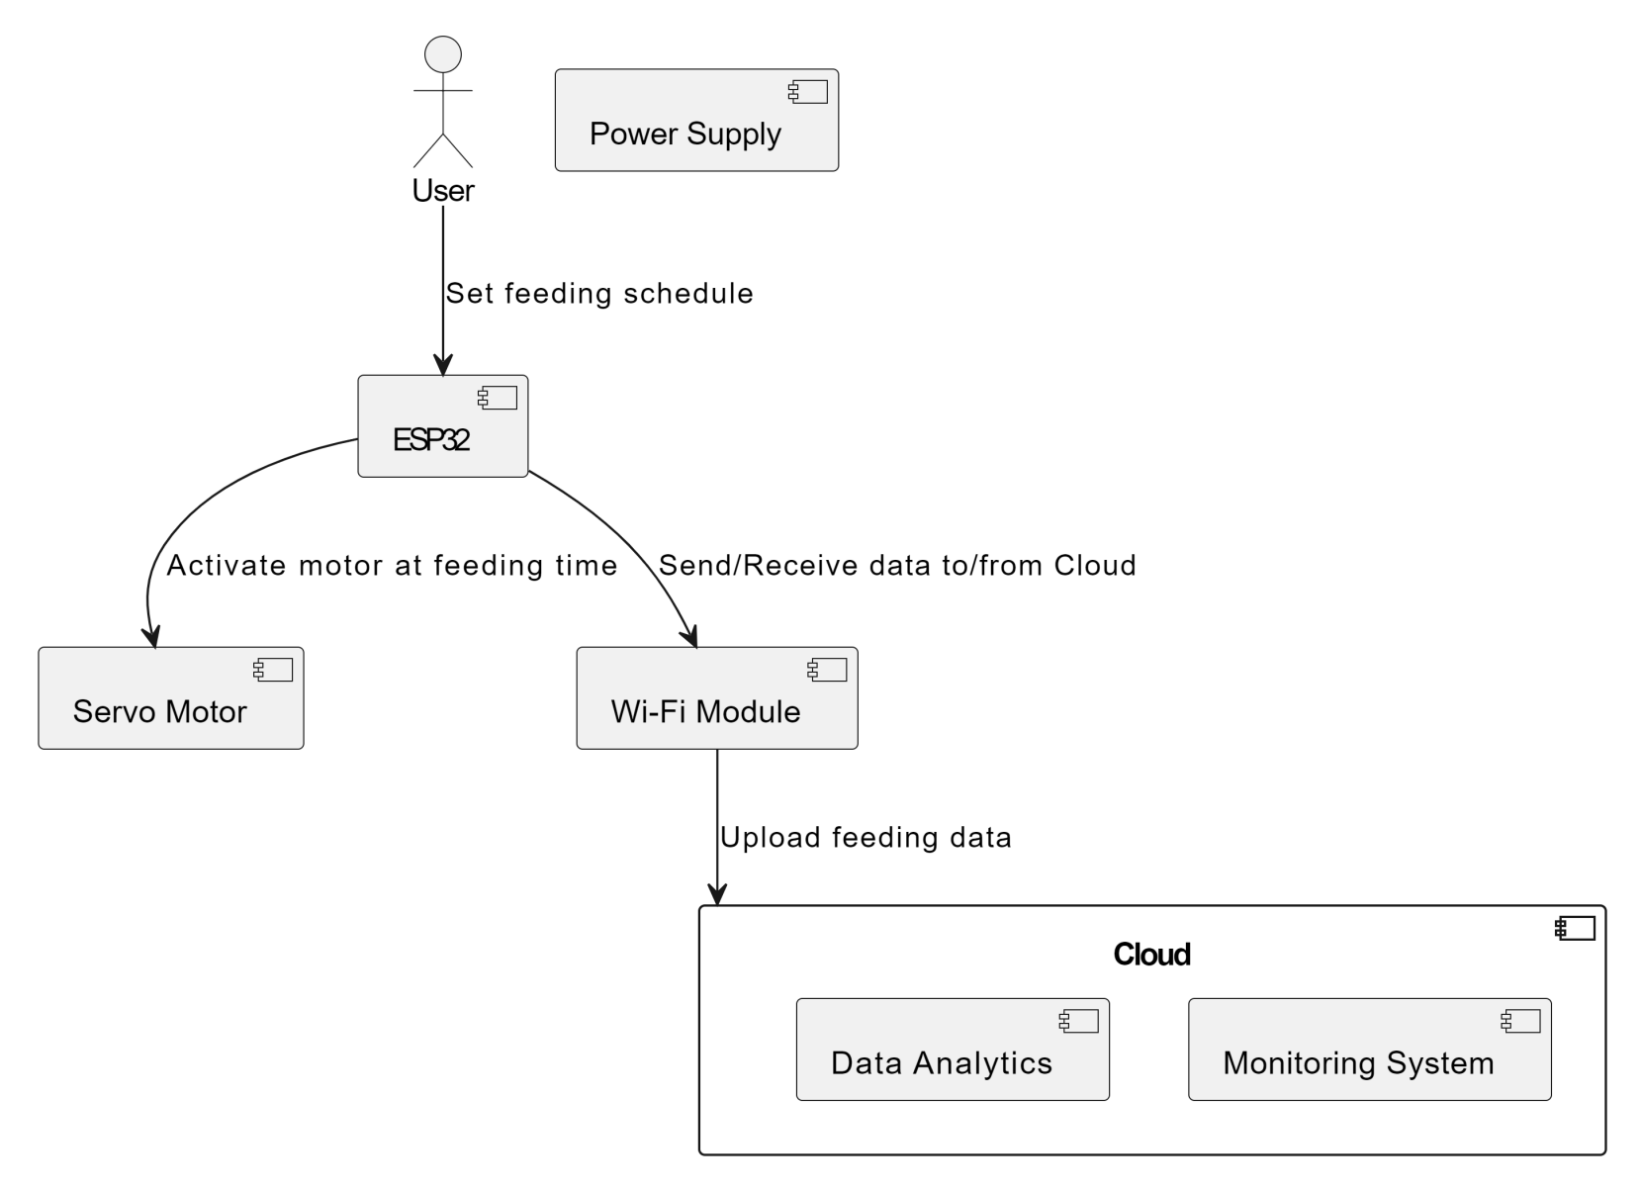

FIG 2.1 BLOCK DIAGRAM

2.1.2 ESP32 Wi-Fi Module:
- The ESP32 acts as the central controller of the system. It is responsible for controlling the servo motor and handling communication. With built-in Wi-Fi, it allows for wireless connectivity to control and monitor the feeder through an application or cloud platform.
- GPIO pins from the ESP32 are used to send signals to the servo motor for movement.
2.1.3 Servo Motor:
- The servo motor is connected to the feeding mechanism. Based on the signal from the ESP32, the servo motor rotates to release food to the fish. The angle of rotation can be controlled to regulate the amount of food dispensed.
2.1.4 Power Source:
Both the ESP32 and the servo motor need a reliable power source. Typically, the ESP32 is powered by a 5V or 3.3V source, while the servo motor can require 5V.
2.1.5 Jumper Wires:
Jumper wires are used to connect the various components on a breadboard or directly to the ESP32’s GPIO pins. They carry signals between the micro controller and the servo motor.
2.1.6 Cloud Connectivity:
Through the Wi-Fi capability of the ESP32, the system can be connected to the cloud, where the feeding schedule can be controlled remotely. A user can monitor the system and set automatic feeding times.

2.2 Module Description

2.2.1 Servo Motor:

The servo motor is the key actuator in the automatic fish feeder system. It controls the movement of the feeding mechanism, ensuring precise food dispensing based on the programmed schedule. The servo motor is designed to allow precise control over angular positions, making it ideal for controlling the release of food from the feeder. When the micro controller sends instructions to dispense food, the servo motor rotates to the specified angle, releasing a measured quantity of fish food into the tank or aquaculture system. The servo motor is essential for maintaining accuracy in food portions, preventing overfeeding or underfeeding, which can affect the health of the fish.
2.2.2 ESP 32 WIFI Module:
The ESP32 Wi-Fi module serves as the central micro-controller of the system, responsible for managing the automation and communication processes. It interprets user inputs, such as feeding schedules and portion sizes, and sends corresponding signals to the servo motor to initiate the feeding process. Additionally, the ESP32 enables remote control and monitoring through Wi-Fi, allowing users to adjust feeding settings, monitor food levels, and receive alerts via a connected smartphone or web interface. The module's low power consumption and built-in Wi-Fi capabilities make it ideal for integrating IoT features into the fish feeder.
2.2.3 Jumper Wires
Jumper wires are used to establish electrical connections between the various components of the system, including the ESP32 Wi-Fi module, the servo motor, and any additional sensors or power sources. These wires ensure reliable communication between modules and facilitate the smooth operation of the automatic fish feeder. The use of jumper wires allows flexibility in the layout of the system, making it easy to modify or expand the circuit if needed.
2.3 Software Requirements
- Arduino IDE Software
The Arduino IDE is the primary development environment used to write, compile, and upload code to the ESP32 Wi-Fi module. It supports programming in C/C++ and offers a user-friendly interface for controlling the various components of the automatic fish feeder. Through this software, feeding schedules and servo motor controls are programmed and managed.
- Blynk (Cloud Application)
Blynk is an IoT platform that allows users to create mobile and web applications for controlling hardware remotely. It will be used to connect the ESP32 Wi-Fi module to the cloud, enabling remote control and monitoring of the fish feeder system. Through the Blynk app, users can adjust feeding times, check the status of the feeder, and receive notifications about food levels or system errors from anywhere
2.3.1 Hardware Requirements
2.3.2 Servo Motor
The servo motor controls the dispensing mechanism, ensuring precise release of fish food as per the programmed schedule. It allows for accurate movement and portion control in the fish feeder system.
2.3.3 ESP32 Wi-Fi Module
The ESP32 acts as the central micro controller in the system, handling communication, automation, and processing. It controls the servo motor and manages the connection to the Blynk cloud platform, enabling remote control and monitoring.

2.3.4 Jumper Wires
Jumper wires are used to connect the ESP32 module, servo motor, and other components on the breadboard, enabling communication between the modules and ensuring the smooth operation of the fish feeder system
2.3.5 Servo Motors
A servo motor is a type of rotary actuator. It consists of a DC motor, a position sensor, and a control circuit that interprets the signal from the controlling device(ESP32).
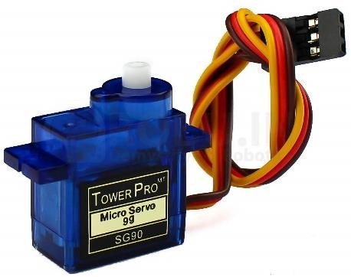
Fig 2.7.1 Servo motor

Servo motors are essential components in Fish Feeder and it is responsible for Serving Food by making rotation. So it is being Controlled by a micro controller (ESP 32 WIFI Module). A servo motor consists of a DC motor, gear train, control circuit, and position sensor. When a person needs to Feed the food for Fish so the data sends to the micro-controller, which makes the process and gives the food by rotation with help of Blynk(Cloud Website) where it can be used for mobile application or peripheral devices . This is being making an rotation accordingly for feed the food by not giving more quantity or less quantity of Food for the Fish . The main role about the Servo motor is rotation of giving food. So the Person have two options with help of blynk :
1)Automatic Option:
The Automatic Option is about the timer to feed the food for Fish.By keep time delay for an particular hours a day.
2.3.6 ESP 32 WIFI MODULE

The ESP32 is a powerful, low-cost, and versatile micro controller with integrated Wi-Fi and Bluetooth capabilities. It is widely used in IoT projects due to its high performance, energy efficiency, and extensive feature set. The chip is equipped with:

Dual-core processors

Multiple GPIO pins for connecting various sensors and actuators

A rich set of peripherals such as ADCS, DACS, PWM, and more

Wi-Fi (802.11 b/g/n) for wireless communication

Bluetooth 4.2 (BLE + Classic) for short-range connectivity

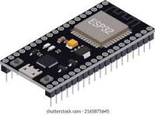

Fig 2.3.6 ESP32

2.3.7 Circuit diagram:

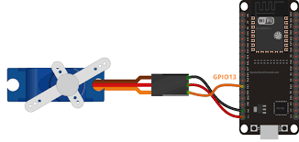

Fig 2.3.7 CIRCUIT CONNECTION
CHAPTER 3

CODE IMPLEMENTATION

Source Code:

#define BLYNK_TEMPLATE_ID "TMPL3Q-Gf11Bj"
#define BLYNK_TEMPLATE_NAME "Smart Fish Feeder"
#define BLYNK_AUTH_TOKEN "uWrUHC4g9-8MVJf0LbUtGZydmHp3vuV7"

#include <WiFi.h>
#include <BlynkSimpleEsp32.h>
#include <ESP32Servo.h>

char auth[] = BLYNK_AUTH_TOKEN; // Auth Token from Blynk
char ssid[] = "Galaxy M3110F8"; // Your Wi-Fi name
char pass[] = "xwxa3912"; // Your Wi-Fi password

Servo servo;
int servoPin = 13;
int fishCount = 0; // Initial fish count
bool isServoOn = false; // Flag to check if servo should rotate

BlynkTimer timer;

void rotateServo() {
if (fishCount > 0) {
for (int i = 0; i < fishCount; i++){

servo.write(90); // Rotate 90 degrees
delay(1000); // Hold position for 1 second
servo.write(0);
delay(1000);
}
}
void periodic Feed()
{
if (isServoOn && fishCount > 0) {
rotateServo(); // Feed based on the same fish count every 6 hours
}
}

BLYNK_WRITE(V0) {
isServoOn = param.asInt(); // Get switch state from Blynk
if (isServoOn && fishCount > 0) {
rotateServo(); // Rotate based on fish count if switch is on and fish count > 0
timer.setInterval(6L * 3600L * 1000L, periodicFeed); // Set the timer to feed every 6 hours
}
}

BLYNK_WRITE(V1) {
fishCount = param.asInt(); // Get fish count from slider
if (fishCount == 0) {
Blynk.virtualWrite(V0, 0); // Turn off the switch if fish count is 0
}
}
void setup() {
Blynk.begin(auth, ssid, pass);
servo.attach(servoPin); // Attach the servo motor to pin 13
servo.write(0); // Initialize servo to 0 degrees

}

void loop() {
Blynk.run(); // Run Blynk
timer.run(); // Run the Blynk timer
}

Flowchart

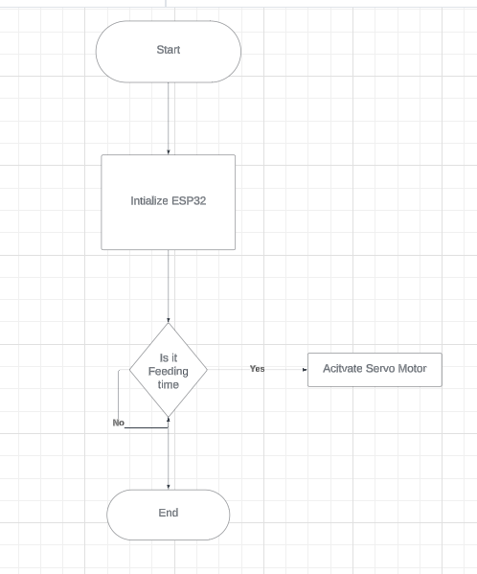

FIG 3.1 FLOWCHART

Experimental Results

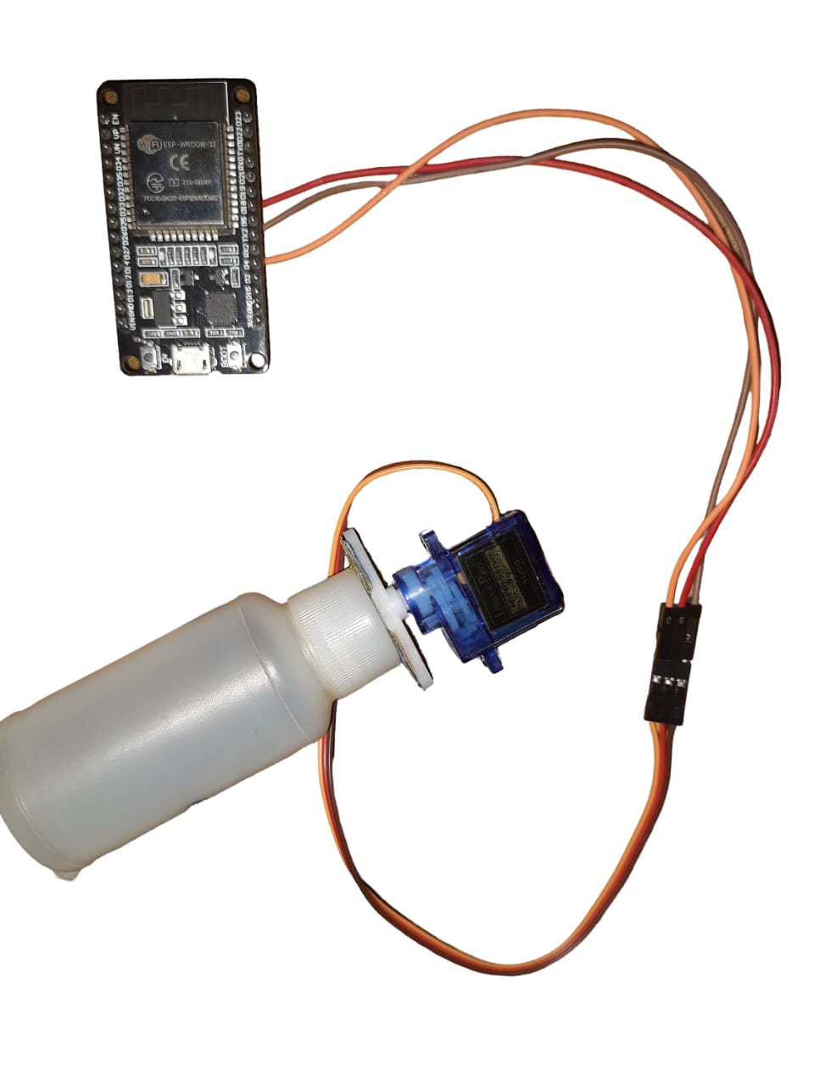
Fig 3.2 Project Prototype

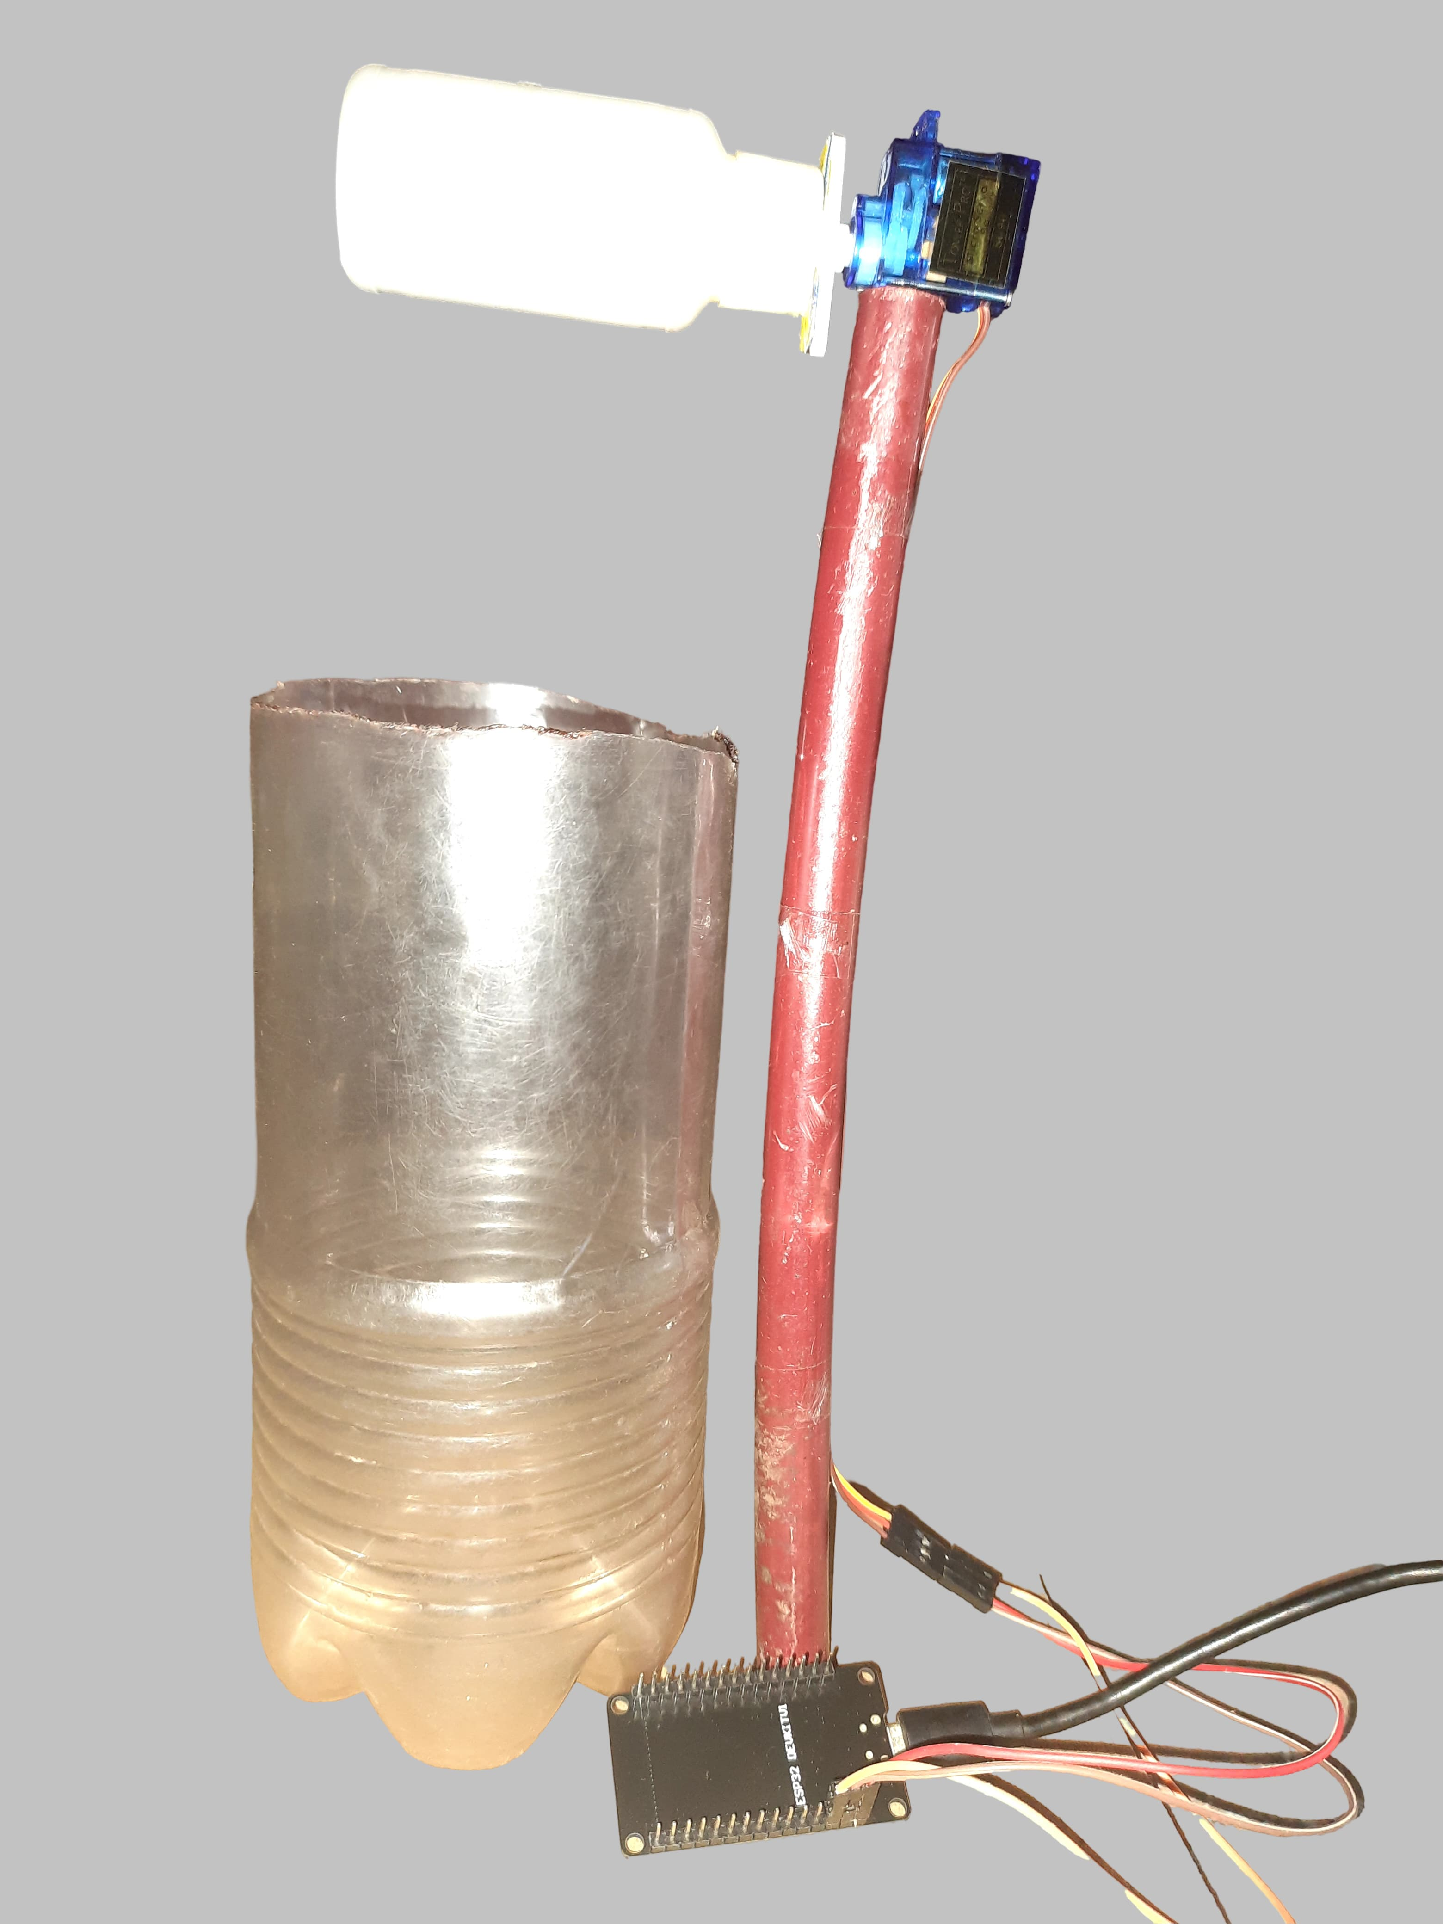

Fig 3.3 Final Setup Result

CHAPTER 4 CONCLUSION

The Automatic Fish Feeder project represents a significant advancement in aquaculture technology, combining automation with ease of use to enhance fish feeding practices. By utilizing the ESP32 Wi-Fi module and a servo motor, this system ensures that fish receive their feed at precise intervals, promoting healthy growth and reducing waste. The integration of real-time monitoring and scheduling capabilities provides users with flexibility and control over their feeding routines. This project not only addresses common challenges faced by aquaculture enthusiasts but also highlights the potential of IoT in improving operational efficiency. As we continue to explore advancements in automation and smart technologies, this fish feeder can serve as a foundational model for future innovations in the field. Ultimately, the Automatic Fish Feeder aims to simplify aquaculture management, making it accessible to both novice and experienced fish keepers alike.

REFERENCES
- IOT-Based Smart Fish Feeder System Using ESP32 from IEEE Xplore:
https://ieeexplore.ieee.org/document/9270624
- Design and Development of Automatic Fish Feeder Using IoT for Aquaculture Systems from ScienceDirect:
https://www.sciencedirect.com/science/article/pii/S235214618300027
- Development of IOT-Based Fish Feeder System for aquaculture Automation From MDPI:
https://www.mdpi.com/2079-9292/10/6/22

